[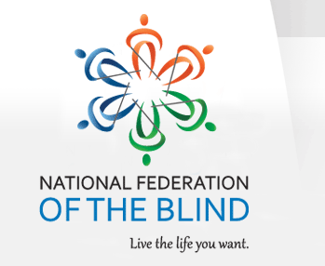](https://nfb.org/reflecting-the-nfb-brand)

The National Federation of the Blind of Florida is now accepting student scholarship applications for 2024 in recognition of their achievements and professional aspirations. Recipients will receive their scholarships at the 2024 Annual State convention scheduled for the weekend of Friday, October 11 through Sunday, October 13 in Jacksonville, Florida. Recipients of the scholarship will have their expenses covered by the Florida Affiliate to attend the State Convention: including travel to and from the convention, hotel room, a daily stipend, registration and banquet.

Qualified high school seniors and college students must complete the scholarship application form in MS word format, write a 500-word essay, provide two letters of recommendation, and submit their academic transcripts.

All documentation must be return to:

**Denise Valkema Chair**

**NFBF Scholarship Committee**

**Email:** **scholarships@nfbflorida.org**

**Telephone: (305) 972-8529**

The National Federation of the Blind of Florida will be awarding three scholarships, each in the amount of $1,500 at the National Federation of the Blind of Florida annual convention banquet on Sunday evening, October 13, 2024.

Completed applications are due no later than September 13, 2024, at 11:59 p.m.

For your convenience, the scholarship application, scholarship checklist, and scholarship guidelines are attached to this correspondence.

For more information you can contact the scholarship chair, Denise Valkema via Email or mobile number located in this correspondence.

Sincerely,

Denise Valkema, Scholarship Chair

2nd Vice president

National Federation of the blind of Florida

Board of Directors