BREAKING NEWS
Newsletter
Issue 8 July/August 2017
President’s note:
Greetings Federation Family,
Florida shined at NFB national convention with 195 registered and about 80 at our caucus. Thanks to all who volunteered during the convention! I enjoyed spending time with individual members and chapters during the convention. It would be nice to hear what our members enjoyed and learned on our NFBF-L list on www.nfbnet.org.
The 2018 NFB national convention will be the last one in Florida for the immediate future. It would be great to be first in attendance and for many of our Florida federation family to plan now to attend.
I hope you have enjoyed a break from teleconference meetings and are ready to start planning for “Meet the Blind Month” activities in October. Please, mark your calendars to participate on our upcoming teleconference calls. We value your participation!

Sincerely, Denise Valkema, President NFBF
Remember we want your tips, stories, recipes, chapter activities, here in the Newsletter.
Find us on twitter and FB @nfbflorida.
Denise Valkema, President NFB OF Florida
president@nfbflorida.org
Facebook & Twitter @nfbflorida
We are filled with hope, energy and love by participating in the National Federation of the Blind. Every day we work together to help blind people live the lives they want.

Announcements and Comments:
The Florida Division of Blind Services is pleased to announce the recipients of the "Successful 75" Awards. The program recognizes individuals, organizations and businesses that have remained steadfast in the advancement of independence for persons who are blind and visually impaired. Throughout the year-long anniversary celebration, 75 honorees were bestowed with this honor.
"We are pleased to recognize these dedicated individuals and organizations as members of the Division of Blind Services' Successful 75," said DBS Director Robert L. Doyle. "The recipients have worked tirelessly to make a difference in their communities through outreach, advocacy, hiring practices and via their individual commitments to achieve self-sufficiency. Through these efforts, Florida continues to strive to become a barrier-free environment for residents with visual disabilities." Paul Martinez was one of the "Successful 75" and here is the bio which was published in DBS recent Newsletter:
Paul Martinez, is passionate about learning policies and procedures that help the blind and visually impaired community. A resident of Tampa, Martinez is currently majoring in social work. He has proudly held several positions within the National Federation of the Blind of Florida since 2011. He currently serves as first vice president of the state board of directors, president of the Florida Association of Blind Students, and president of the Florida State Wide Chapter of the National Federation of the Blind of Florida. ​See photo in photo gallery.
The Fundraising Committee met, and discussed several ideas. The committee concluded with the holiday Calendar Raffle. We proposed to the state affiliate that each ticket be sold for $5 each, that the drawling will take place from November 1st through November 30th, Monday through Friday the winner will win $25, Saturday and Sunday the winner will win $75, and on Thanksgiving the winner will win $100. The fundraiser was approved by the state affiliate, and the process of ordering tickets is on its way.

Birthdays & Celebrations:
The NFBF would like to celebrate:
Birthdays:
July:
Steve Blum - Suncoast
Sheila Clayton- Tallahassee
Sherrell O’Brian - Tampa
Ron Whittum - Treasure Coast
James Young - Tallahassee
August:
Michelle Curtis - Tampa
Doug Ingram - Tallahassee

Anniversaries:
Jackie and Gordon Bowman - Tallahassee
Monique Bowden – Tallahassee

NFBF Calendar: You can also find important dates on our Webpage
Miami Pilot Bell Academy: July 31st to August 4th, 2017
President’s Committee: August 13, 2017
State Board: August 27, 2017, 8pm
Empowerment Committee: August 28, 2017
NFB411 Call: September 10, 2017 - The topic is all about Meet the Blind Month
Communication Committee August 22, 2017, 8pm
NewsLine Committee: TBA
Senior Concerns: TBA

Legislative Updates:
The National Federation of the Blind, the leading membership organization of blind Americans, opposes H.R. 620, the ADA Education and Reform Act, as currently proposed. President Riccobono states: We firmly believe that H.R. 620 would make meritorious ADA lawsuits much more difficult and expensive, yet would not affect the very small number of lawsuits that have most concerned the proponents of the bill. In addition, it will decrease access by removing any incentive for businesses to identify and correct access barriers proactively. We need to increase access.
NFB Opposes Privatization of Interstate Rest Areas. President Riccobono comments: An integral part of building and raising those expectations is the ability to obtain employment and remain self-sufficient. One of our divisions, the National Association of Blind Merchants, is the largest organization of blind entrepreneurs anywhere in the world. While such legislation may seem harmless, we are certain that it will have a devastating effect on blind vending machine operators who service those rest facilities under the Randolph Sheppard Vending Facility program, which gives priority to blind vendors. If your proposed bill is passed, it will undeniably cause a significant number of blind vending machine operators to lose their job.
Please continue to contact your representatives on the following legislation:
Accessible Instructional Materials in Higher Education (AIM HIGH) Act (H.R. 1772)
Access Technology Affordability Act (H.R. 1734) (S. 732)
Appropriation to the National Library Service for the Blind and Physically Handicapped (NLS) for the Purchase of Refreshable Braille Devices
The Marrakesh Treaty to Facilitate Access to Published Works for Persons Who Are Blind, Visually Impaired, or Otherwise Print Disabled
Transitioning to Integrated and Meaningful Employment Act (TIME Act) (H.R. 1377)
Equal Access to Air Travel for Service-Disabled Veterans

Technology: Tips & Tricks
Apple Tips and Tricks from Camille Tate
While ever changing technology can make day to day communication easier, it can also be difficult for the blind to adapt. The Siri function for the iPhone is a wonderful tool to navigate through the features on your device, but there are some things she can’t perform. It’s always a good idea to learn all the shortcuts to make using your device simpler and less frustrating. Below are two tips or tricks (take your pick) that can make using your phone a little easier.
• Conference Calling: Some of us attend meetings using a conference call service. To make it easier to access the call-in number and enter the PIN for the specific meeting, do the following: In your contacts, type the following string: conference call number, followed by two or three commas and the access code. It should sound like this: 123-456-789,,,12345#. The commas insert a one second pause that is necessary for the phone system to ask for your access code. If you are the host of the meeting, then insert two or three commas after the # sign, followed by * eight.
• You can’t hear your apps on the home screen: There are times when we scroll our finger across our home screen, searching for a specific app. Or, we are trying to listen to the voiceover and all we hear is “bloop”. Try this simple trick and see if it works. Ask Siri, either by pressing the home button or saying, “Hey Siri”. Ask Siri to turn off voiceover. Wait about a minute, then ask Siri to turn on voiceover. Most of the time it works. Sometimes the voiceover only needs to be reset.

Inspiration Conner:
“When I let go of what I am, I become what I might be.” ― Lao Tzu
Chapter, Division, and Committee updates:
Greater Broward Chapter: Tom Ryan, President; Phone: 954-442-1855, Email Ryantom@bellsouth.net.

Central Florida Chapter: Sherri Brun, President; Please like us on Facebook at: https://www.facebook.com/groups/410985858949160. We meet the third Saturday of each month from 11:00am to 1:00pm at Lighthouse Central Florida, 215 East New Hampshire Street, Orlando, Florida 32804.

Greater Daytona Beach Chapter: Joshua Espinal, President, Phone: 407-534-0160 We meet the fourth Saturday of the month 11:30am to 1:30pm at TGI Friday's, 24 Ocean Shore Blvd., Ormond Beach FL 32176. Follow Us on Facebook: www.facebook.com/nfbdaytona.

Gainesville Chapter: Judith Hamilton, President; Phone: 352-373-7806, Email: gainesville_nfb@earthlink.net. The Gainesville Chapter welcomes you to our monthly chapter meetings. Our meetings are held the second Saturday of each month from 2:00PM to 4:00PM, with meet and greet at 1:00PM. We meet at the Northwest Grille, 5115 Northwest 39TH Avenue, Gainesville, Florida.

Greater Jacksonville Chapter: Marita Winston, President; Phone: 904-323–8597, Email: marita.winston60@gmail.com. Please join us if you are in the area. Upcoming activities: Summer Party at the Comer Museum August 12, 2017; Jack’s Community Fair Saturday, September 16, 2017; where we will participate in the Jack’s 5K Heart Walk. We will wear our NFB T-shirts with pride and network with other organizations and businesses. We are also planning several “Meet the Blind Month” events in October.

Greater Miami Dade Chapter Jorge Hernandez – President; Phone: 305-877-2311; Email: jeh1065@comcast.net. Our meetings are held on the third Thursday of each month. Location: Denny's Restaurant, 5825 N. W. 36 Street, Miami, FL.

Melbourne - Space Coast Chapter: Joe Naulty, President; Facebook: www.facebook.com/nfbmelbourne. We meet on the second Saturday of each month at The Fountains, 4451 Stack Blvd, Melbourne, FL 32901 from 9:30 a.m.-12:00 p.m. Anyone needing transportation, please call Joe Naulty, (321) 768-9500.

Palm Beach Chapter: Tekesha Saffold, President; 561-707-4799; Email: tnsaffold82@gmail.com. We have monthly meetings on the second Saturday of every month at 4746 North Congress Avenue, Boynton Beach, FL 33425.

Pinellas Chapter: Janice Snow, President; Phone: 727-303-4307; email; mojokitty50@gmail.com. Our meetings are held on the third Saturday of the month at Applebee’s, 5110 E Bay Drive in Largo. We meet for lunch at noon and the business meeting starts at 1:00pm. Paul Martinez, 1st vice president, and Miranda Kilby, 2nd vice president will attend our meeting in August to discuss membership building. We are working hard to change what it means to be blind in Pinellas county.

Polk Chapter: Joe King, President: Phone: 863-293-5648; Email: joenkitty@earthlink.net. Our meetings are held the second Saturday of the month at: Winter Haven Manor, 140 Avenue A S.W., Winter Haven, Florida, at 10:00am-12:00pm.

FL State Wide Chapter: Paul Martinez, President; Phone: 813-390-5720; Email: nfbf.statewide@gmail.com. The State-Wide Chapter invites you to join us on our conference call on the third Sunday of every month at 8:00pm. This chapter was designed for those who do not have a local chapter or for some reason cannot get to their local chapter for any given reason. We have been busy the last few months undertaking a fundraising project to assist members attending our national convention. We are pleased to announce the conclusion of our Omaha Steaks raffle. A huge congratulation goes out to our two winners, Leslie McKinnley and Brooke Edwards. We thank everyone who supported the State Wide in this fundraising project. In our next meeting, we will be discussing upcoming goals, and encourage everyone to attend the meetings.

Suncoast Chapter: Lauren Blum, President; Phone: 352-584-0795; Email: laurenblum79@gmail.com. Meetings are held on the second Saturday of each month from 1:30 pm to 3:30 pm at IHOP,3660 Commercial Way, Spring Hill, FL 34606. The Chapter had a great opportunity to eat lunch with President Valkema and a few members of the state affiliate during the national convention. We have been selling our snack packs at our local Lions Club, since their kitchen is temporary closed. We are working hard to be involved in the community and Living the life we want.

Tallahassee Chapter: Jada Christie, President; Phone: 850-766-9378 Email: emeraldpink15@gmail.com. We meet the 1st Monday of each month and the Lighthouse of the Big Bend, Tallahassee, FL 32303. Tallahassee is pleased to announce that we had one Kenneth Jernigan Scholarship winner and two State sponsorship awards at the National convention. Join us for our upcoming Applebee’s Flapjack fundraiser September 9, 2017at 8am.

Tampa Chapter: Miranda Kilby, President; Phone: 352-942-0417; Email: NFBF.Tampa@gmail.com. Join us the fourth Saturday of every month. The chapter has been extremely active. In the month of July, we were driven to assist the state affiliate in their fundraising efforts. We participated in two separate discussion panels for the City of Tampa and a group of engineering students from the University of South Florida. During this meeting, we answered several questions and brought up several concerns. We also engaged in a peaceful educational demonstration in front of our transportation building (H.A.R.T.), and attended their public hearing regarding the propose changes to several routes. We will kick off the month of August strong by attending a board meeting of H.A.R.T., where they will be deciding the changes to the buses.

Treasure Coast Chapter: Tim Edwards, President; Phone: 630-432-5090; Email: tred34990@gmail.com. Come join the Treasure Coast Chapter of National Federation of the Blind for its monthly meeting on Saturday June 10th, from 10am till noon at WQCS Radio Station @ IRSC, 3209 Virginia Avenue, Fort Pierce.

Florida Association of Guide Dog Users (FLAGDU): Sherrill O'Brien, Division President; flagdu@nfbflorida.org

Deaf-Blind Division: Darlene Laibl-Crowe, President; Email: Nfb.florida.deafblind@gmail.com. The FL Deaf-Blind division meets on the first Tuesday of every month at 8:00pm. If you are interested in attending this meeting and learning what the division has; please contact the president.

Florida Organization of Parents of Blind Children (FOPBC): The Parents Division is being reorganized by Kimberly Banks, Email: kimberlybanks1984@gmail.com

Florida Association of Blind Students: The FABS invites any high school or college student to attend our conference calls on the third Sunday of every month at 6:00pm. For further information, contact the president, Joseph Chica at 305-333-10335 jhc102@miami.edu. To call into our meetings use conference number 641-715-3274 and access code 401665.

Committee to Empower Underserved Populations: Marilyn Baldwin, Chairman, 8427 Lainie Lane, Orlando, Florida 32818, 407-293-0565, CommMDB@aol.com

The National Association of Blind Veterans: Dwight Sayer, President; 321-948-1466; Email: president@nabv.org; PO Box 784957, Winter Garden, Florida 34778.

Photo Gallery:
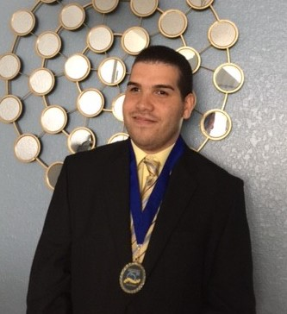

Paul Martinez receiving the Successful 75 Award from DBS.

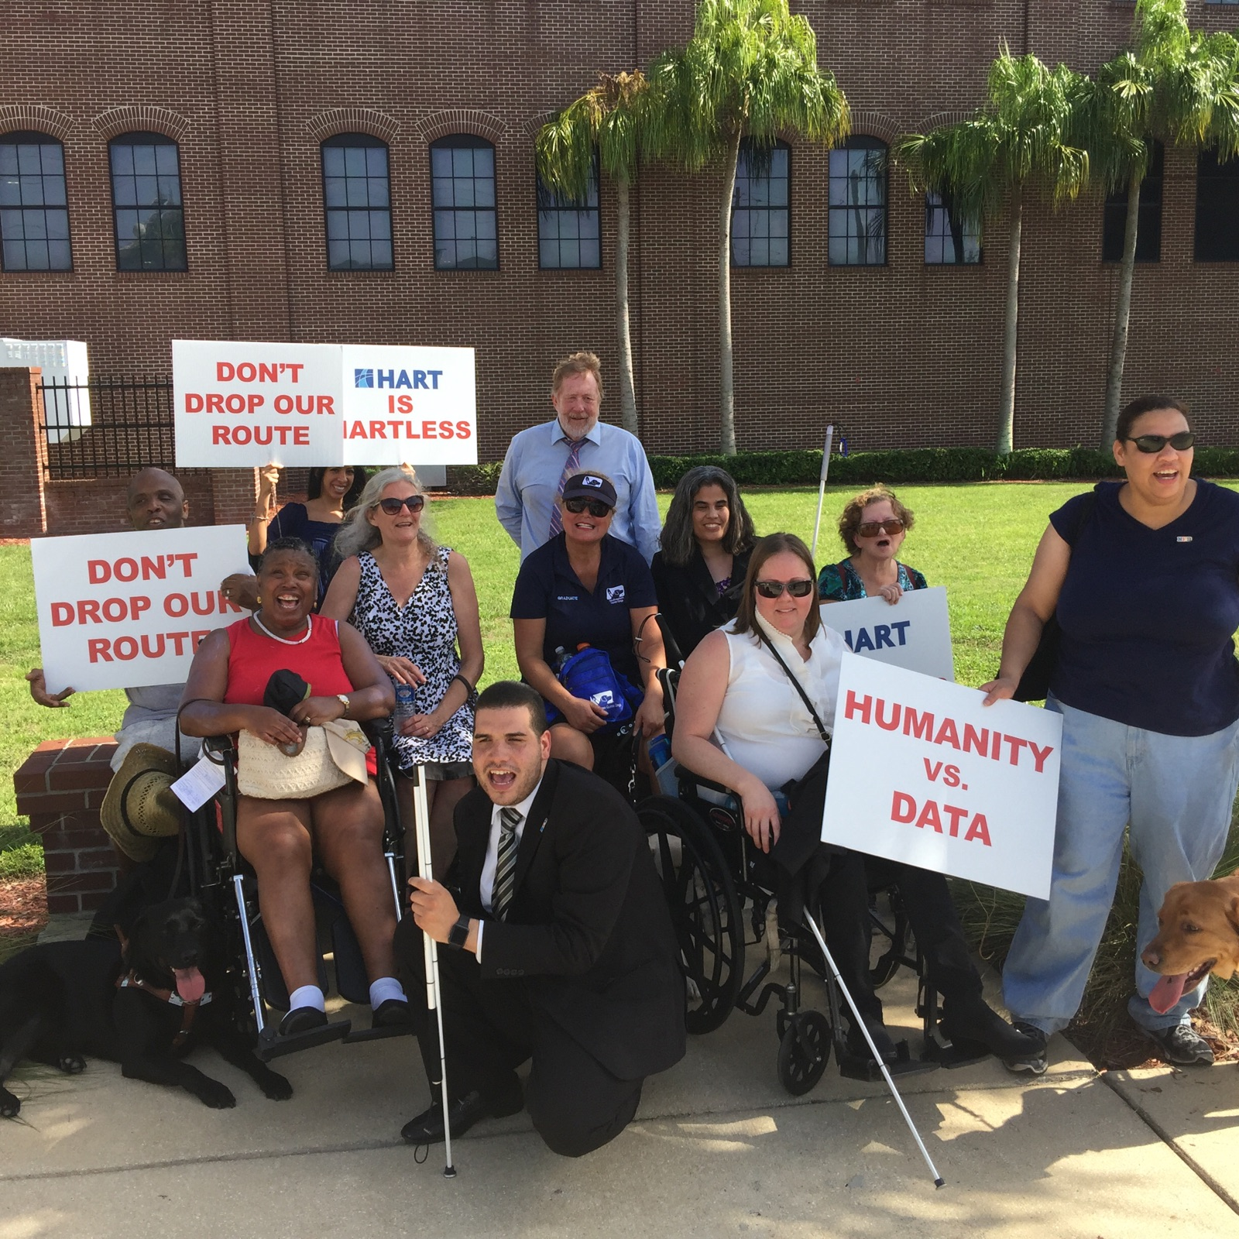
Tampa Chapter’s peaceful educational demonstration in front of our transportation building (H.A.R.T.)

Please contact any of the board with questions, comments, concerns or for general information.
NFBF Board of Director’s Information:
Denise Valkema -President
Phone: 305-972-8529
Email: president@nfbflorida.org

Paul Martinez - 1st Vice President
Phone: 813- 390-5720
Email: paul09ms@gmail.com

Miranda Kilby – 2nd Vice President
Phone: 352- 942-0417
Email: mbkilby@gmail.com

Sylvia Young-Secretary
Phone: 850- 322-5937
Email: secretary@nfbflorida.org

Gloria Mills –Treasurer
Phone: 813-340-9754
Email: glorianfbf@gmail.com

Board Members:
Tekesha Saffold
Phone: 561-707-4799
Email: tnsaffold82@gmail.com

Jorge Hernandez
Phone: 305-877-2311
Email: jeh1065@comcast.net

Camille Tate
Email: Yankiecat1999@cfl.rr.com

Rafael Fernandez
Phone: 305-903-6299
Email: rafael.fernandez0617@gmail.com
Editor: Sylvia Young
To have something posted in the NFBF Newsletter please submit it to the editor, Sylvia young at secretary@nfbflorida.org by the 15th of each odd month.

